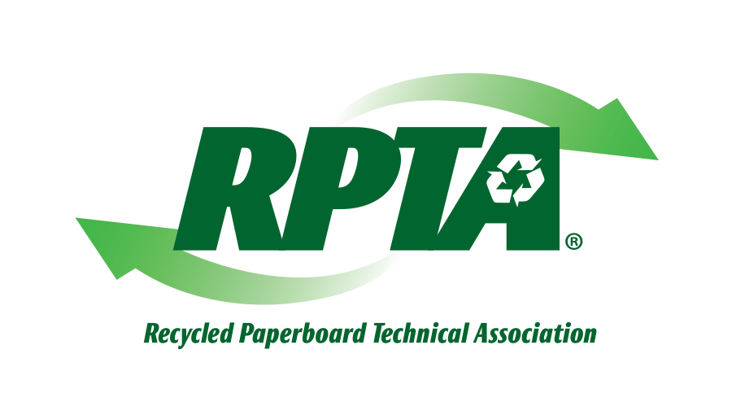

**RPTA’s ANNUAL ROUNDTABLE**

Marriott Courtyard, Billy Graham Parkway

Charlotte, NC

September 16 – 17, 2014

**MEETING INFORMATION AND AGENDA**

The subject of RPTA’s Annual Roundtable is Vacuum Systems. The program will begin on September 16 at 1:00 PM.  The first day will feature presentations by representatives of CVN Vooner Paper Machinery and include a tour of the CVN Vooner plant to demonstrate a pump test.  The evening will conclude with a dinner for attendees, graciously sponsored by CVN Vooner.

The second day will continue with presentations and an open discussion, followed by an optional tour of the Caraustar, Carotell mill. The agenda is as follows:

**September 16**

1:00 - 1:15 PM Welcome and Introductions

1:15 - 2:30 PM How liquid ring vacuum pumps work

2:40 - 3:50 PM Vacuum pump maintenance and troubleshooting

4:00 - 5:00 PM Plant visit for a pump test

6:30 - 9:00 PM Dinner and Drinks

**September 17**

8:00 - 8:40 AM Uhle box, showers, separators system design and application

8:40 - 10:00 AM Cost of operation, Life Cycle Cost or Total Cost of Ownership of new stainless rotor/cone pumps versus rebuilding cast iron pumps

10:00 - 10:10 AM Break

10:10 - 10:30 AM Variable speed vacuum pump for extending felt performance and saving energy.

10:30 - 11:00 AM LRVP remote Monitoring and Communications for Sustainability and Reliability

11:00 - Noon Open questions and discussion

Noon – 6:00 PM Optional tour of Caraustar’s Carotell Mill